4 The Room
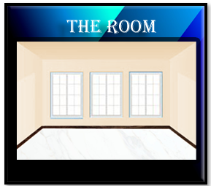

What is the Room?
Rooms, is where everything happens, if you don’t have a room, you will not be able to have a game. You must have a room. But a room, doesn’t need to be a room, it can be a field, or a lake, or even inside of a red -hot volcano. Game Maker doesn’t care what environment that you throw into that room, but all of your action takes place within “The Room”. You can have as many rooms as you want, but you have to have a least one room, or you won’t have a game.

Rooms
Click or create a new room in the Asset Browser. We have a room called my first room
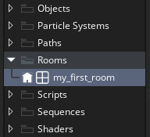
Look at the left, the dimensions of this room, might be a bit off for the size of our floor tiles, and some things might be cut off if we kept it this size.

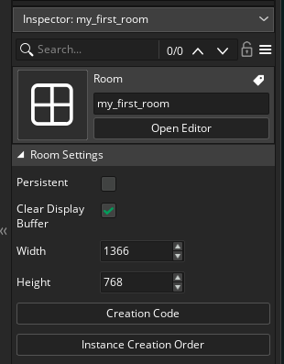
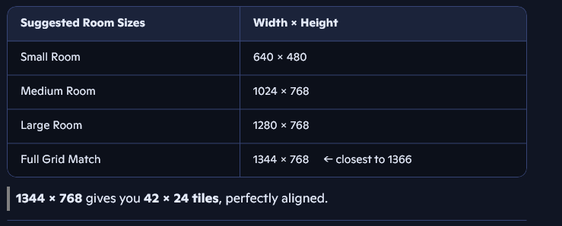
So, I just changed the width, to 1344, the height can stay the same.
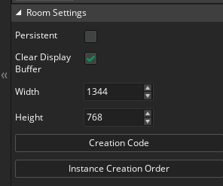

Go to your Rooms to be able to add tiles. Click on the text, that says “my_first_room” Of course your room might be named something different. But just click on the text that is here. You will not see your palette yet.
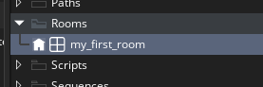
Now Create a layer in the left side of the screen.
To create a new layer, Click on the Plus sign first Name it Floor_Tiles
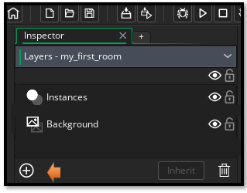
Select Tile.

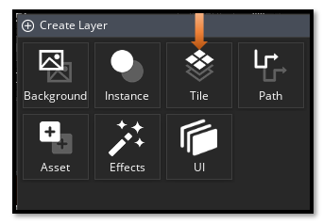
Name your new Layer Floor_Tiles.
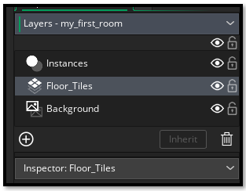
Choose your tile set that you created in the tutorial in this series on tiles.
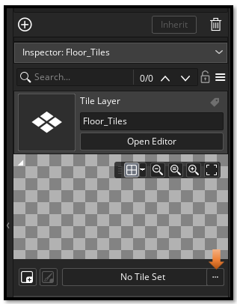
Go into your Tile Set folder and choose tls_basic, which is what we called our tile set.
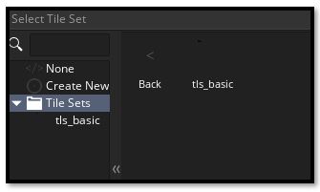
Now you can see your tile palette on the right side of the screen. First Make sure that you do have the Floor_Tiles layer selected.
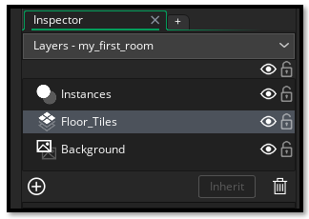

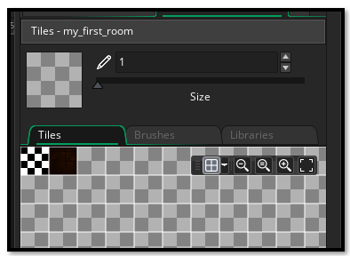

Moving the Palette Around.
If you do not see your tiles. Hit the square at the end of the tool menu above it.
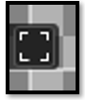
To Zoom, use the Zoom button, To Move around, hold down the space bar and move the palette around with your mouse.
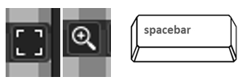

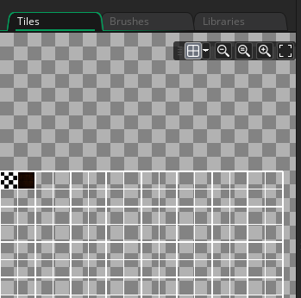
To add a tile to the board, just click on the tile you want to add and then drag and drop it onto the board.

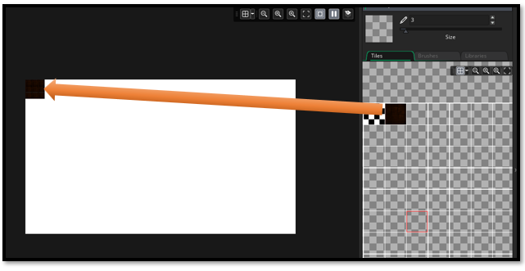

Finish laying all the tiles and now you have the floor.
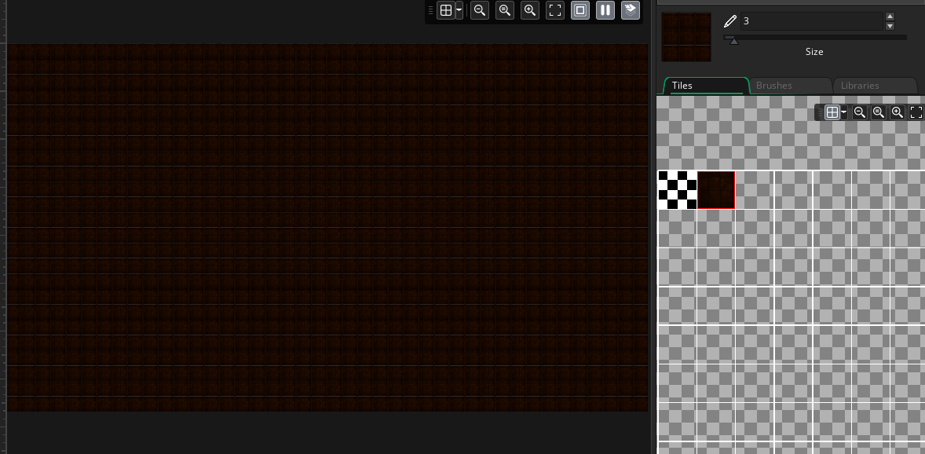

That is all there is to creating the room, and placing the floor tiles into it. Next, we will be taking a look at how we can go about creating a wall around the room.

